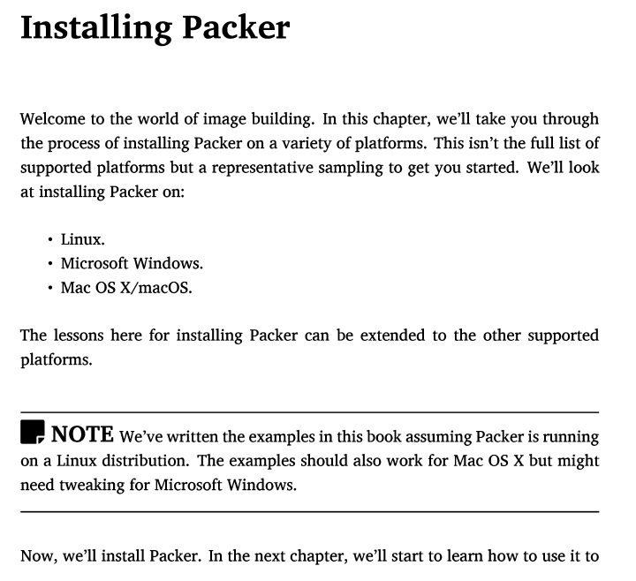

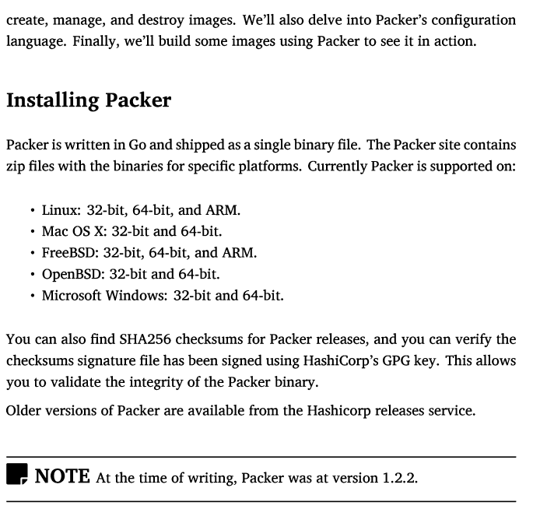

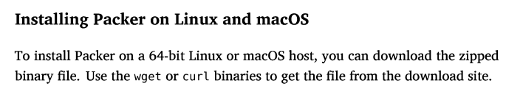

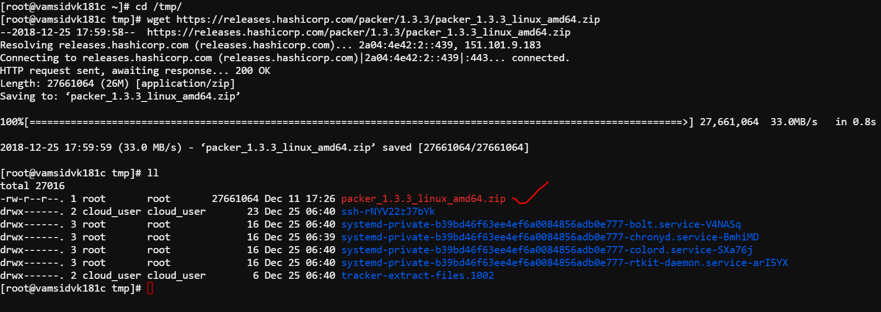



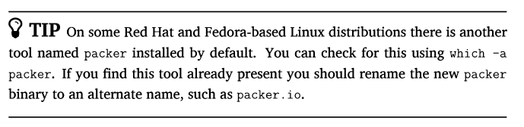

We encountered the same issue in our centos7 OS . So we have to follow above procedure

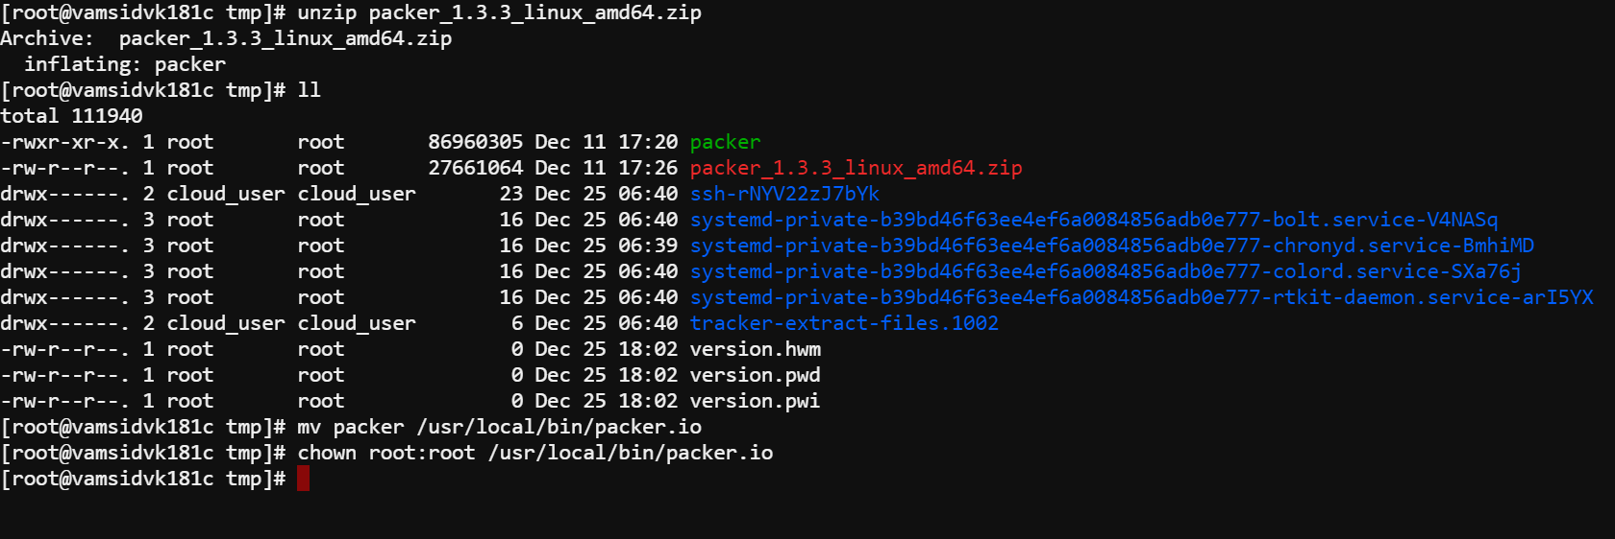



After installing remove the existing packer binary which is deduced from which -a packer and move the downloaded and extracted packer binary to /sbin folder and try packer version

